A METHOD OF COUNSELING ON LINE USING THE ELEMENTARY PRAGMATIC MODEL
P. De Giacomo*, L. Mich°, M. Storelli*, S. De Nigris*, A. De Giacomo*,
C. Tarquinio*, R. Masellis*
* Department of Neurological and Psychiatric Sciences
University of Bari, 70100 Bari (Italy)

° Department of Information and Telecommunication Technologies
University of Trento, 38050 Povo - TN (Italy)

ABSTRACT

The project of “Counseling On Line” has about twenty-years experience in relation to interactive psychotherapy, whose theoretical bases are in the Elementary Pragmatic Model (EPM) and whose aim is to get a better self-awareness. The EPM has a relational genesis, and can be defined as a system of classing human interactions and the way they can change. The EPM individualises 16 Relational Styles or Functions (named from F0 to F15), and the possible interactions among them, which are summarized in the “Table of Paradoxes”. The EPM gives us a “grid” of reference during the practice in a systemic meaning, both in the range of psychology and psychopathology; it enables us to provide the patients with some “containers”, that is to say some mental constructions, that make it possible to view a different prospect in the interpretation of one’s mind and in the vision of one’s world. The Counseling On Line uses the application of “Compass Sentences”, that come from the Table of Paradoxes, and then are the transformation of the varied possibilities of interaction according to the EPM. Such sentences may be a guidance for the subject’s life and are able to kindle in him an amplification of his mental horizons. The relation on line with the user has to happen according to a counseling contract based on “a better knowledge of oneself”. It develops in ten sessions focused mainly on the choice of the user of sentences deriving from the EPM and on their elaboration partly free, partly EPM guided. The subjects are also provided with a MPE grid of valuation of themselves, and a final feedback about the validity of the work that has been done by the user.

Keywords: Counseling On Line; Compass Statements; Elementary Pragmatic Model; Cognitivism; Short Interactive Psychotherapies; Internet; Therapeutic Techniques in E-Therapy (The Wheel Of Wisdom; Scriptotherapy, Creativity, Flexibilization Of Mind, etc.).

INTRODUCTION

The EPM has already been used in the range of electronic communication and different papers confirm the attempts of its application [1,2,3,4,5].
The research that our group is treating concerns its use aimed, in the Counseling on Line [15], and utilizable also in the educational range, of sentences with a strong psychological impact that we consider are able to interfere in the basic mechanisms of the organization of the human mind, thus forming a sort of aggregation and organization of thoughts, “a compass for mind”, a kind of “password for mind”. Experimental evidence led us to a conclusion: we noticed, in our professional practice related to the clinic and psychotherapy carried out both with single subjects and with their families, that some phrases were particularly incisive and important to start a subject’s therapeutic change. For this reason, a methodical work started, to research and pick out the phrases able to be used as an instrument of knowledge, of reflection on the constructions of mind, of opening to innovative ways of interaction.
When we speak about “sentences with a strong psychological impact” we make reference to innovatory, original, rather short phrases, involving, able to be conclusive to a meaning emotional input for the persons they are proposed to, that “whet their mind”; these sentences embrace, and have to do with, in the user’s opinion, an important topic of his life, and, thus, in that moment of his life, are capable to describe synthetically but clearly the peculiar features of a problem of his.
The “Table of Interaction” was used for the production of the statements endowed with the above said characteristics; it bases itself on a model of the mind, the Elementary Pragmatic Model (EPM).
The EPM, in fact, gives us a “grid” of reference during the practice in a systemic meaning, and allows us to provide the subjects with some “containers” (regulators of mind, organizers, mental constructors, invariants) [6,7,8,9,10,11,12] able to make possible a plain, lucid, definite interpretation of one’s own mind and thought. Such containers then, represent a language that is different from the usual one, but is effective in whatever way, because it is capable of getting out of the common schemes of thought, that tend to be homeostatic by nature, and therefore not suitable for change.
The proposed model enables the user to learn to change the results of his mind into clear, determinate and original “mental constructions” (the sixteen functions of the EPM), that will help him to understand the working of his mind and to analyse it in a new way in comparison with the past. A new key of reading himself and his own mental life is, after all, committed to the subject.
The reframing, re-definition, new setting of one’s mental contents constitutes a fit remedy of psychotherapeutic kind, since they lead the user to throw over his schemes of thought that kept him with a homeostatic mental organization.

Theoretical bases of the Elementary Pragmatic Model
The theoretical order of the EPM is articulated on four levels of growing complexity: an elementary level (of the triads); a second level (of the four co-ordinates); a third level (of the sixteen functions or rather of the sixteen relational styles); a fourth level (of the Table of Interaction).

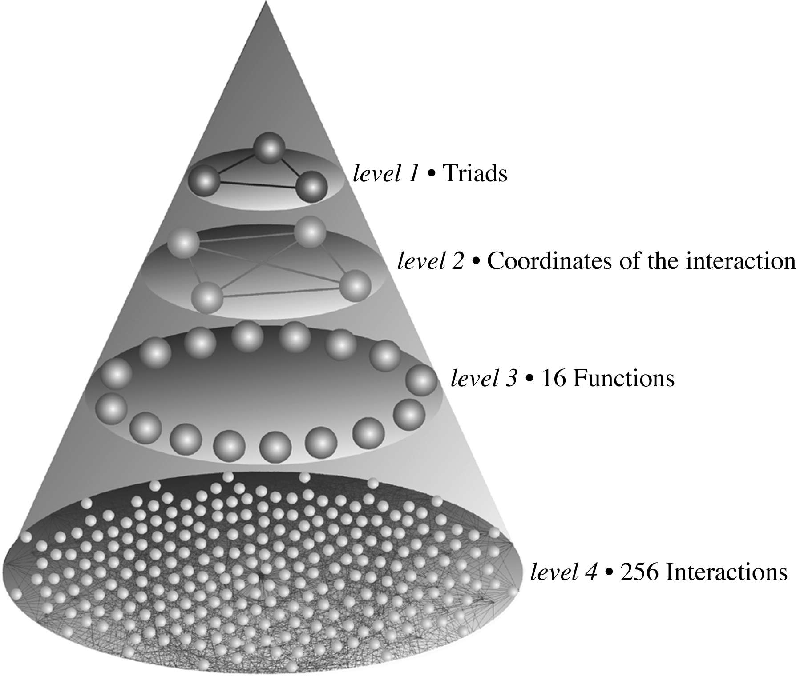

1) Elementary Level (of the triads)
The development of the EPM starts from observing the interaction between two subjects, and from its analysis inside an elementary binary model. The communicative exchange can set up in triplets: “Shannon’s triads”. Every triplet comprises: the first interacting subject’s proposal (expressed in a binary language); the second interacting subject’s proposal (this one binary, too); the result of the interaction, which means how the first interacting subject was transformed in consequence of the interaction with the second one.

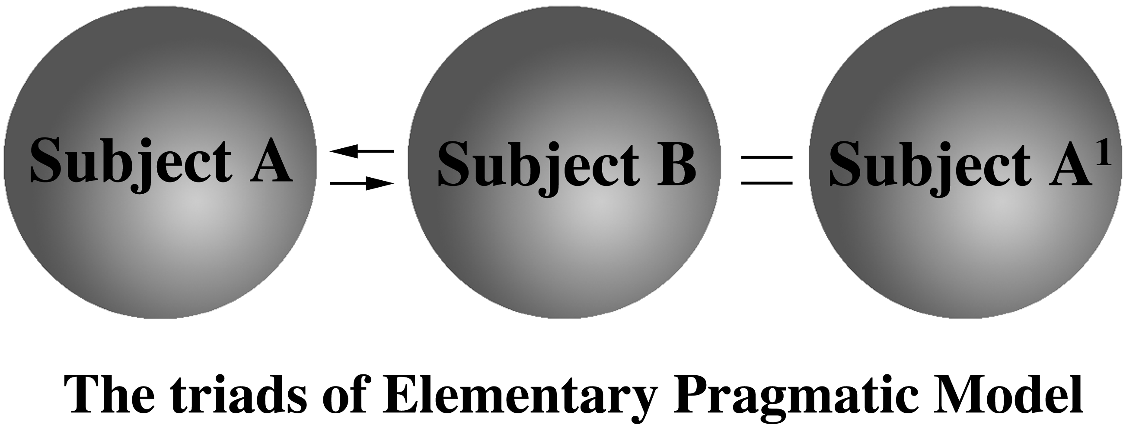

2) Second Level (of the four co-ordinates)
The triplets make it possible for the graphic definition of four spaces of dyadic interaction, represented with Venn’s diagram in which: the circle on the left side represents the first interacting subject’s world, the circle on the right side represents the second interacting subject’s world; the intermediate part represents the intersection (the elements that are common to both the subjects’ worlds); everything of the circles is what’s outside the interacting worlds. Each of these components can be full or empty. Thus four co-ordinates of the interactions are defined: acceptance, maintenance, sharing, and antifunction.

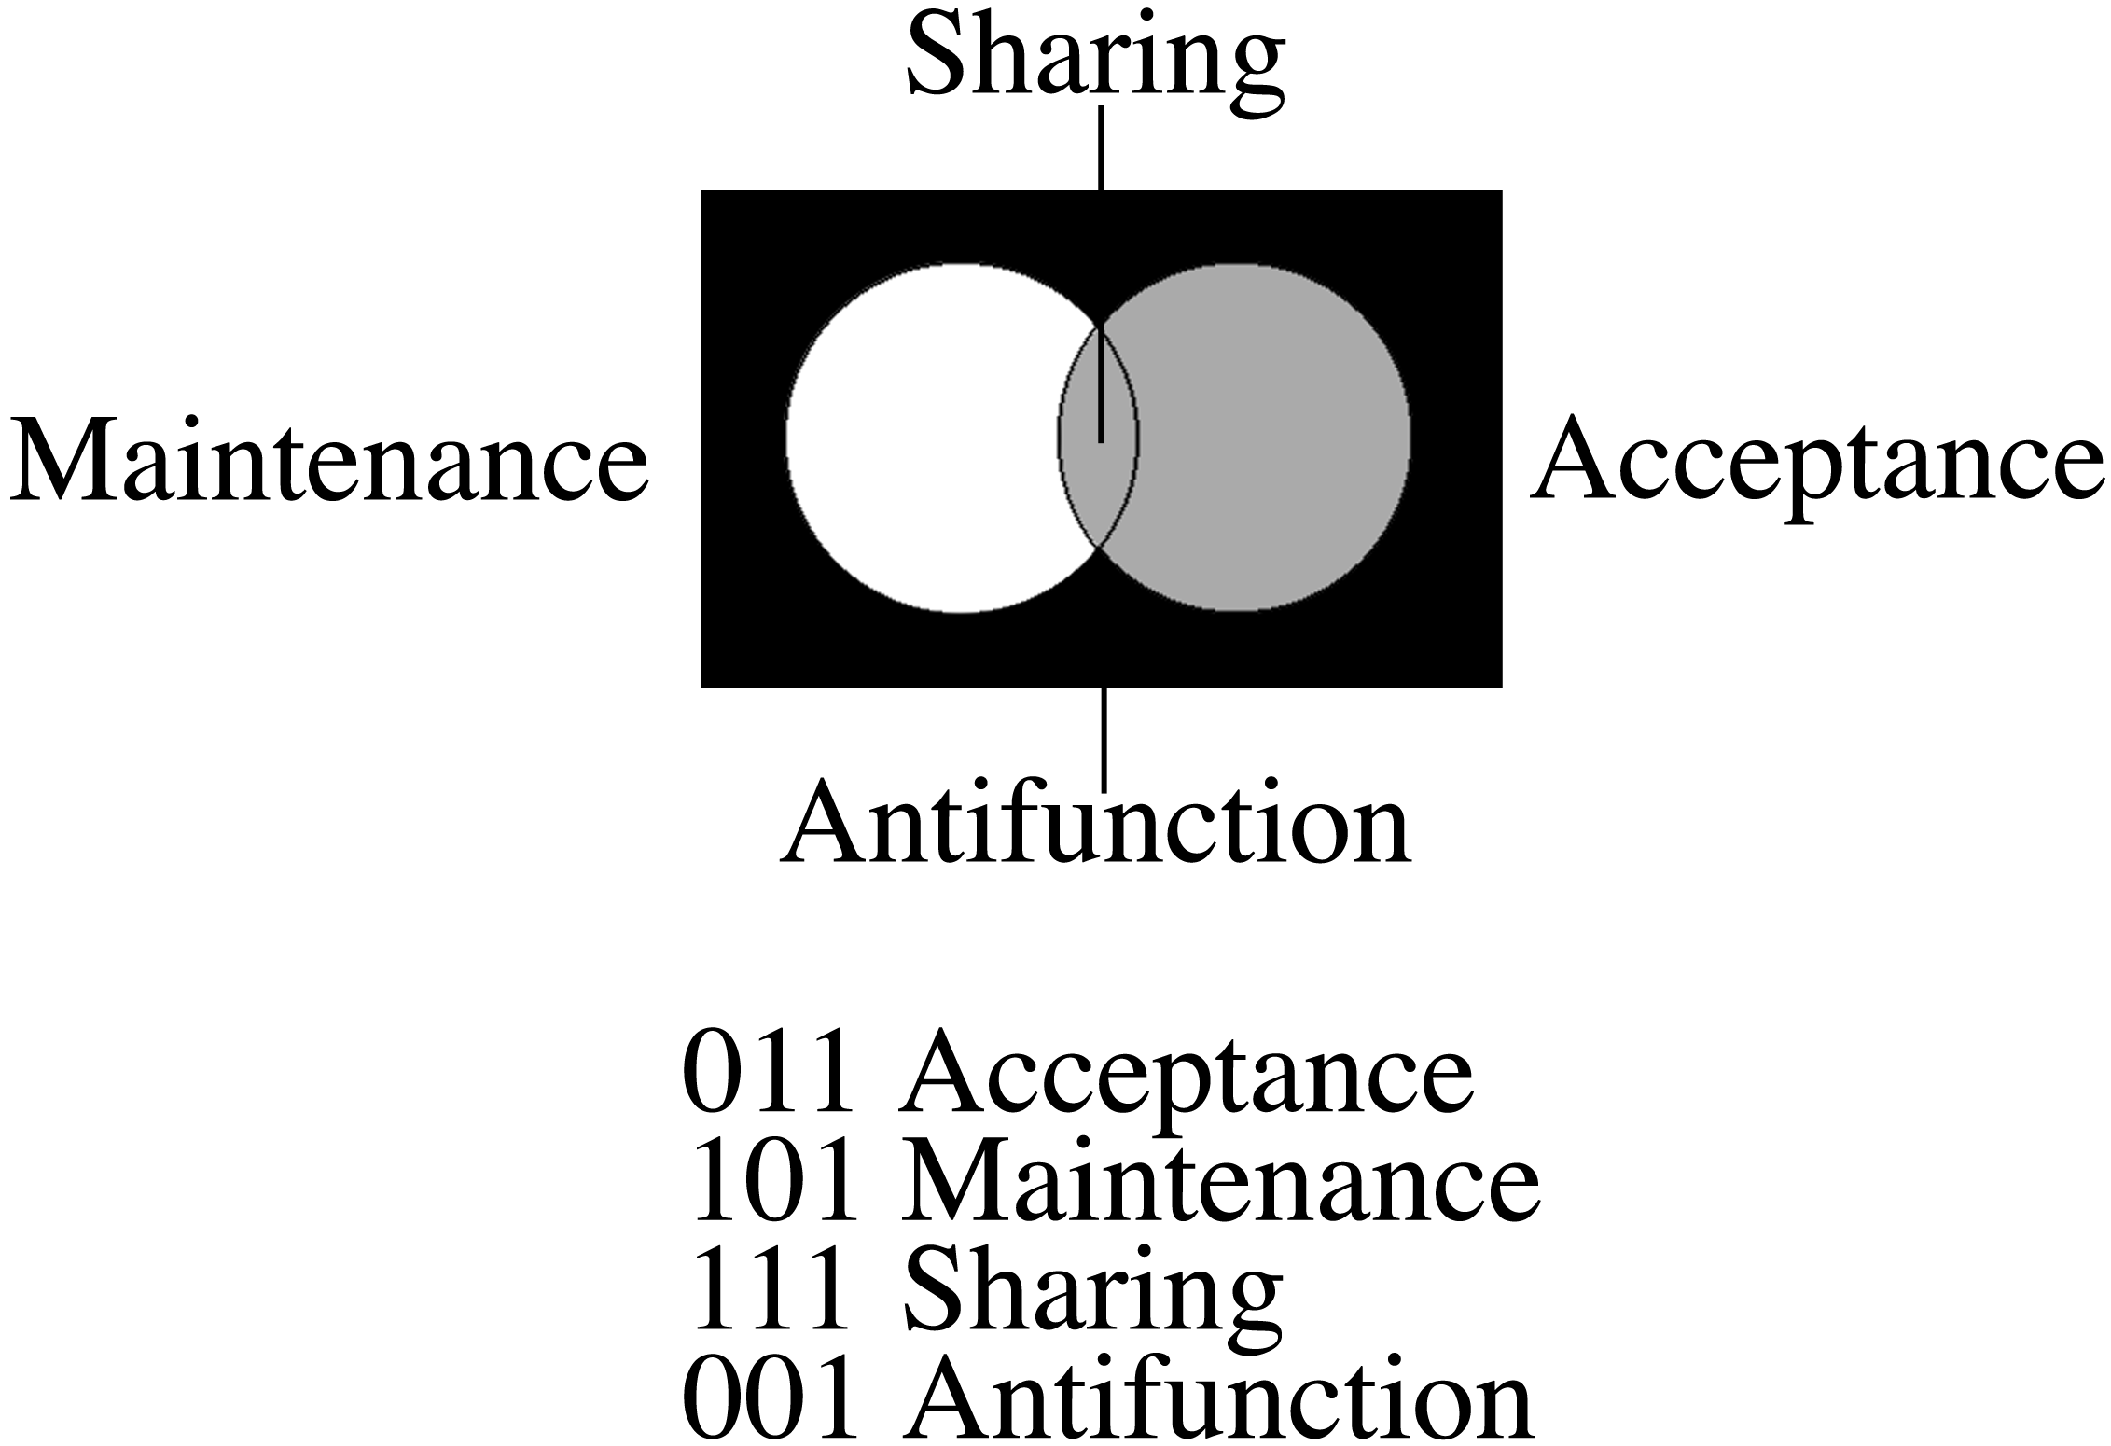

3) Third Level (of the sixteen functions or of the sixteen relational styles)
The combination of the four components of the four co-ordinates gives rise to the sixteen functions or relational styles (from F0 to F15).

Sixteen interactive styles

F0 The subject who obliterates him/herself in the relation

F1 The sharer

F2 The acceptor of one’s own world only

F3 The maintainer of one’s own world

F4 The acceptor of the other’s world without sharing

F5 The acceptor of the other’s world

F6 The acceptor of one’s own and of the other’s world, without sharing

F7 The acceptor of one’s own and of the other’s world

F8 The acceptor of what only exists neither in one’s own nor the other’s world
F9 The acceptor of what only exists, or does not exist, in one’s own and in the other’s world

F10 The anti-other or “Mary-Mary quite contrary"

F11 The complete maintainer of one’s own world, with tendencies to expand

F12 One who, while accepting the other’s world without sharing, and while accepting what exists neither in one’s own nor in the other’s world, behaves like a maintainer of one’s own world

F13 The exaggerated acceptor who refuses solely what exists in one’s own world

F14 The total acceptor who is nevertheless unable to share

F15 The total acceptor

Such styles correspond to the following Venn’s diagrams:

4) Fourth Level (of the Table of Interactions)
The interaction of the sixteen relational styles among them leads to 256 possibilities, that are depicted in the Table of Paradoxes. As you can see, from this table the “Compass Sentences”, that are used in this research, take origin. The use of the table is rather easy: vertical is representing the first interacting subject (for example, the patient), and horizontal the second (for example, the therapist). If the “patient” adopts a certain relational style and the therapist adopts another one, through crossing the two functions we’ll read how the patient was transformed by the relationship with the therapist.

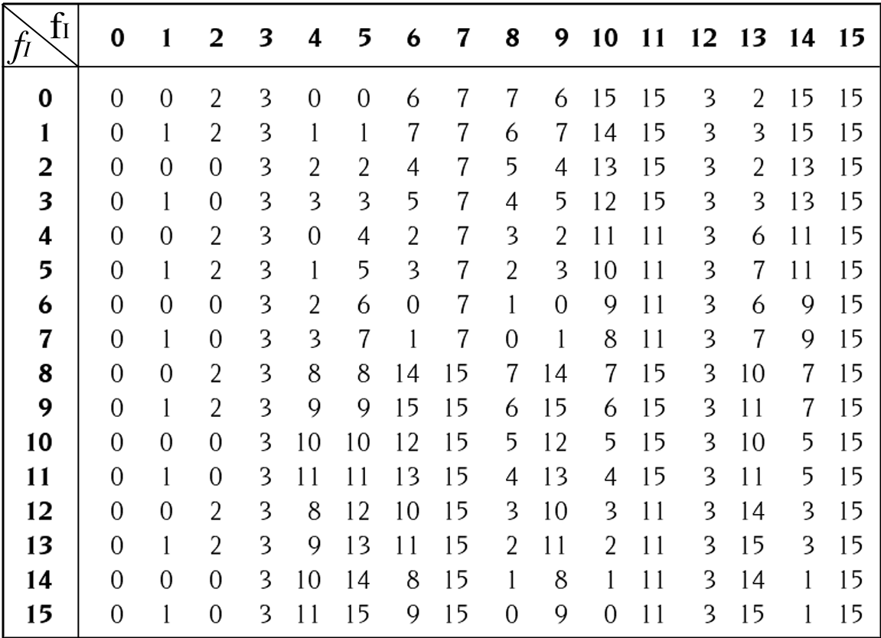

From the Elementary Pragmatic Model to an applicative test to define the relational characteristics of the subject

To make the relational styles (third level of the clinical practice) clear and utilizable in the clinical practice, a college of experts of the EPM arranged to choose, among all the proposed adjectives, the most suitable ones to represent the corresponding functions. So we got the following list of couples of adjectives that is used in the test “The Way You See Yourself” [16]:

f₀ – empty/absent
f₁ – participant/sharer
f₂ – solitary/reserved
f₃ – tenacious/egocentric
f₄ – docile/surrendering
f₅ – altruist/involved
f₆ – mysterious/ambiguous
f₇ – collaborative/mediator
f₈ – abstract/unpredictable
f₉ – sharing/innovative
f₁₀ – rebel/antagonist
f₁₁ – dominant/dictatorial
f₁₂ – double faced/false-altruist
f₁₃ – unpredictable/altruist
f₁₄ – inconclusive/disorganized
f₁₅ – confused/chaotic

From the outcomes of the test you can deduce the relational pattern of that subject. In other words, different subjects use, in their interpersonal relations, patterns that have different percentages of relational styles. This test, as we’ll see, is part of the programme that has to be executed on-line.

Formulation of the “Compass Statements”
Such phrases, which are obtained from the Table of Paradoxes, using the logic of the Model and the operators’ creativity and experience, were selected on the ground of the impact they caused on varied samples of population.

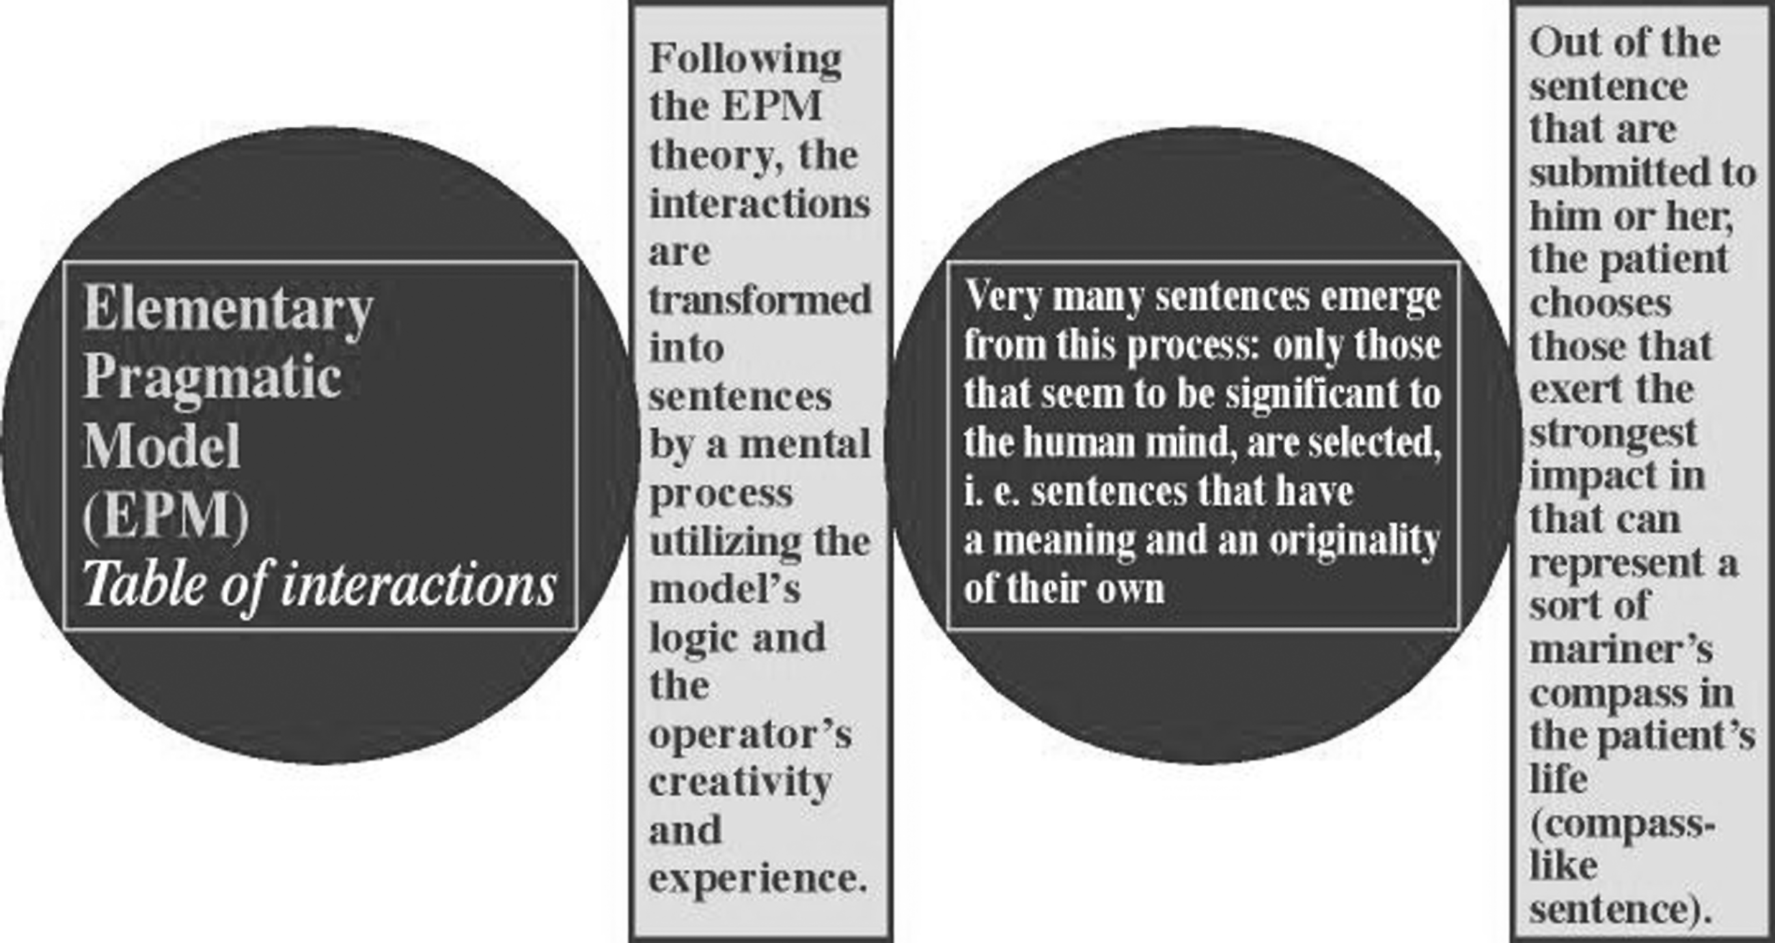

After the experimentation, it appeared that some statements, more than others, resulted statistically significant. Actually, we are working with a group of 31 sentences (an interaction corresponds to each of them) that we purpose in the Counseling on Line. Examples of application of the sentences are the following ones (the formula of their origin from the Table of Paradoxes is written below each phrase and enclosed with parentheses, there’s the number of each phrase in the group of the above said 31):

1. (9) Having a goal is already achieving a goal.

EPM: F9 II F15 = F9

2. (12) Uncertainty, doubt, ambivalence, doubtfulness, being swayed by the waves, if this is a state that repeats, repeats, in the end it nullifles you, it kills your mind.

EPM: F6 II F6 = F0

3. (19) lf you pursue a goal creatively, if the outcome is positive, in other words leads towards your world, this will make you stronger.

EPM: F9 II F5 = F3

4. (21) When you think you are a great person, the almighty or a genius, or your work seems to you very important and headed for great results and great successes, tell yourself : “I’m in a dream-attack”.

EPM: F14 II F14 = F1

5. (23) True luck is when you get something unexpected that you like.

EPM: F9 II F13 = F11

6. (25) If you want to keep your creativity, feed off chaos.

EPM: F9 II F15 = F9

7. (31) Sequences are interrupted either by nullification or by absolute inflexibility or by total confusion.
EPM: The three final states of EPM (F0, F3, F15).

ON-LINE SENTENCE APPLICATION PROGRAMME: COUNSELING ON LINE

The relation on-line with the user – who can be a student in Educational contexts – has to happen, in our opinion, according to a contract whose objective is the attainment of a clear aim: a better consciousness of himself, that is to say a cognitive investigation of his own mental organization.
The procedure is the following one: the Counseling goes on according to ten sessions, and during each of them the user will choose a sentence among the given ones and will utilize it as a sort of subject whose aim is the investigation of himself: theme of his work will be to explain the reason why he chose just that sentence, to clear up how it managed to get in his beliefs, which associations excites him, which events of his life it recalls, how he’d elaborate the sentence according to a viewpoint of himself, which story he’d create about the sentence. Besides, he’ll be provided with a grid of answers quoted from the EPM, among which he’ll have to individualise the most corresponding to his viewpoint, and, moreover, (but only during the first and the last sitting) the test “The Way You See Yourself” will be administered to him; it defines the features of the user in the relational point of view. At the end of the session, the user will present his elaborate, that will be, if both the therapist and the user think it convenient, discussed in an interactive way by a private “chat”: otherwise, the user will be directly sent to the next session.
At the beginning of the next session on-line, the user will choose a second sentence that’ll have to be worked out in the same way of the first one and possibly discussed in an interactive way with the therapist.
At the starting of the following session a third sentence will be chosen, that will take the same procedure, and so on till the overall duration of the ten sessions.
At the tenth session a general synthesis will be made: interacting with the user, the therapist will try to define what has emerged from the work of the ten sessions and to understand what the user understood about himself; the test “The Way You See Yourself” will be administered again at the end.
Finally, a valuation of the counseling will be made on four levels (excellent, good, middle, zero).

Ways of reply to the user: the feedback of the therapist in the Counseling on Line
If the user likes a feedback given by the counselor by chat, varied kinds of reply are proposed to the users following the programme.
Particularly, sixteen styles of answers are picked out and suggested, arranged in a conceptual point of view according to the basis of the EPM, for instance, the professional authoritative one (F3), the answer aimed at the investigation and the understanding of what the subject worked out (F1), the answer based on pursuing a goal creatively (F9), the answer of the kind in identifying himself with the subject’s world (F5), the ambivalent answer (F6), the mediatory answer (F7), the antithetical answer (F10), the metaphorical answer (F14), the abstract answer (F8), the answer based on entering into the subject’s world beyond measure and paradoxically (F13), the magic answer (F11), the answer of the kind of total acceptance (F15), etc.. In giving the person a feedback, using the sixteen styles of answer, you can proceed both without pre-constituted contents or deriving from a pool of phrases coming from or not coming from the EPM, covering a large quantity of human foreseeable situations. Computerized programmes can also be utilized with the goal of improving the organization of the users’ thought, i.e., for example: “Flexibilization of Mind”, “The Tape of Mind” (that is to say “The Wheel of Wisdom”), “Psychoma”, which are the results of the research work centred in the EPM.

CONCLUSIONS

This initial experimental study has assumed at present the characteristics of a “soft” Counseling, based fundamentally on the subject’s choices, and therefore with the user’s most exclusive liability.
Starting from this input, we intend to get helpful experiences for the goal of improving our on-line interventions with the possibility of developing a real and right systemic and cognitive e-therapy in the next future.
Besides, given the encouraging premises, we are planning to set up a completely automatized service of Counseling in a not so distant future, with a “clever” computer that interacts with the user, and furnishes him with those “password for the mind” able to open new paths for his self-consciouseness.

Keywords: Compass Statements, Elementary Pragmatic Model, Cognitivism, Short Interactive Psychotherapies, Counseling on Line, Internet, Therapeutic techniques in e-therapy (Wheel of Wisdom, Scriptotherapy, Flexibilization of Mind).

REFERENCES

[1] Colazzo L., Mich L., Malinverni Silvestri D., Schal T.: An experiment on computer-mediated communication supported by the coordinator using a pragmatic model. In “Proceedings of the international workshop on computer supported cooperative work”. Gorling K., Sattler C. (Eds). Berlin, 9-11 April. Institute fuer Informatik und Rechentechnik, Berlin; pp.34-58, 1991.

[2] Colazzo L., Mich L, Malinverni Silvestri D., Schal T.: Interpretation of Human Relations in Computer Supported Communication : A Test with A Pragmatic Model. In Stamper R.K. et Al. (eds), Elsevier Science Publisher, Amsterdam, 1991.

[3] Colazzo L., Malinverni Silvestri D., Margoni M., Mich L.: Simulation of communicative situation between subjects using the elementary pragmatic model. In “Proceedings of IASTED International Symposium. Modelling, identification and control”. Hamza M.H. (Ed). Innsbruck, Australia, 18-21 February 1991. Acta Press, Anaheim, CA, pp149-152, 1991.

[4] Colazzo L., Malinverni Silvestri D., Mich L.: An Application of the Elementary Pragmatic Model to Electronic Communication. Ann. Ist. Super. Sanità, Vol.28, 2: 245-252, 1992.

[5] Colazzo L., Mich L., Silvestri L.: User Modelling in Didactic Applications: a Pragmatic Approach. (Cummings G., Okamoto T., Gomez L. Eds.) Advanced Research in Computers and Communications in Education. Vol. I. IOS Press, Tokio, 1999.

[6] De Giacomo P., Silvestri A.: New horizons in psychiatric recearch: The elementary pragmatic approach to the study of interactional behavior, Report presented at the WPA Regional Symposium, Kyoto, April 9-1, 1982.

[7] De Giacomo P., Pierri G., Corfiati L., Silvestri A., Lefons E., Tangorra F.:An Elementary Pragmatic Approach in System- Therapy, “International Journal of Family Psychiatry”, 4: 65-74, 1984.

[8] De Giacomo P., Silvestri A.: An Elementary Pragmatic Model in Family Therapy, “International Journal of Family Therapy”, 6: 245-263, 1985.

[9] De Giacomo P.: The Elementary Pragmatic Model: from Theory to Therapeutic Practice. Ann. Ist. Super. Sanità, Vol.28, 2: 169-176, 1992.

[10] De Giacomo P.: Finite Systems and Infinite Interactions: The Logic of Human Interactions and its Application to Psychotherapy. Bramble Books, Norfolk, Connecticut, USA, 1993.

[11] De Giacomo P. e O.G. Pereira: Psicoterapias Pragmaticas Breves. Tupam Editores, Lisbona 1997.

[12] De Giacomo P., Margari F. Rutigliano G.: Ottimizzazione della visita psichiatrica: ovvero dell’arte modulare dello psichiatra. Ed. F. Angeli, Milano, 1997.

[13] De Giacomo P.: Mente e creatività: Il Modello Pragmatico Elementare quale strumento per sviluppare la creatività in campo medico psicologico, manageriale, artistico e di ricerca. CD-ROM allegato. Ed. F. Angeli, Milano 1999.

[14] De Giacomo P., De Nigris S.: Computer Workbook in Psychotherapy with Psychiatric Patients (Ed. L’Abate L.) Greenwood Publishing Group Westport, 2001.

[15] De Giacomo P., Marconi P.L., Storelli M., De Giacomo A., Giovannelli M., Masellis R., Anelli F., Carrieri G., Lattanzio A., Tarquinio C., Lavorato E.: Un Counseling on Line col Modello Pragmatico Elementare: Ed Schena, Fasano, Italy, 2002.

[16] L’Abate L., De Giacomo P., McCarty F., De Giacomo A., Verrastro G.: Evaluating Three Models of Intimate Relationships. Contemporary Family Therapy 22, 103-122, 2000.

[17] Silvestri A,, De Giacomo, Pierri G., Lefons E., Pazienza M.T., Tangorra F.: A Basic Model of Interacting Subjects, Cybernetics and Systems: An International Journal, 11, 113-127, 1980.

